Membership Form
Preferred Mailing Address (select one) | ☐ Home | ☐ School
Last Name |  |  |  | First Name |  |  |  |  |  | MI
Address |  |  |  | City |  |  | State |  | Zip Code
Contact Number |  |  |  |  |  | Email Address

School Name |  | School Address
City |  | State |  | Zip Code

Organization (check one)
Community/Technical College | ☐
High School/Middle School/Junior High | ☐
Post-Secondary | ☐
Private School | ☐
Skills Center | ☐
Position (check one)
Administrator | ☐
Business Professional | ☐
Teacher | ☐
Retired/Student (no fee) | ☐
Division: (see map below) (check one)
Western | ☐
Central | ☐
Eastern | ☐
Additional Information
FBLA | ☐
DECA | ☐
Dues
WE-BAM
Professional $35; Student $0; Retired $0
NBEA
NBEA/WBEA Professional $149
NBEA/WBEA/ISBE Professional $199
NBEA/WBEA Retired $75
NBEA/WBEA Student $50
WA-ACTE
Professional $75; Retired $35; Student $0
ACTE
Professional $80; Retired $31; Student $0
FBLA Professional $35
Total Enclosed
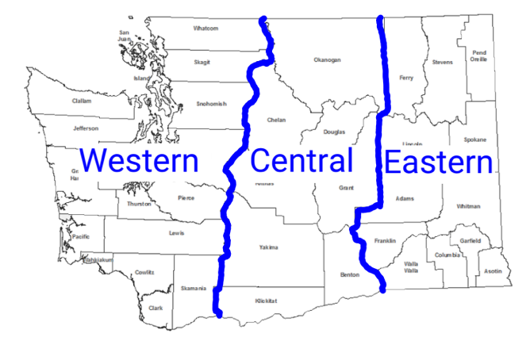
Please send form and payment to
Heather Gallagher, WE-BAM Membership Chair
P.O. Box 729, Goldendale, WA 98620
(541) 980.0960; Heather.Gallagher@gsd404.org
For Official Use

Date Received __________ Amount Received __________

Check No. _____________ Amounts Forwarded:
NBEA/WBEA/ISBE __________
WA-ACTE/ACTE __________
WA-FBLA __________
Confirmation sent ______________

